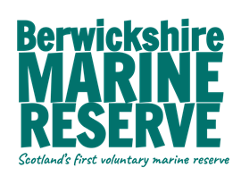

Post: Volunteer Marine Ranger

Closing Date: 5pm, Friday 13th May

Benefits, training, expenses: Training, skills development and contribution to expenses.

Employer: Berwickshire Marine Reserve.

Description: This is an excellent opportunity for applicants to gain interdisciplinary experiences while working with a unique marine conservation charity. The Berwickshire Marine Reserve (BMR), formerly St. Abbs and Eyemouth Voluntary Marine Reserve, encompasses 10.3km² of some of the most diverse and stunning marine environment along the Berwickshire coast, supporting a variety of commercial and recreational interests.

The Marine Ranger Intern will be part of the public/visible arm of the BMR. Activities will include raising awareness of the marine environment through education, public events (particularly along the shore), communications campaigns, community engagement and liaison with stakeholders and user groups. As this role will involve working with children and vulnerable adults, a PVG check will be carried out.

Our Marine Ranger interns will be an integral part of the BMR team ensuring delivery on our programme of summer events and supporting our team undertaking a variety of Citizen Science projects to engage our local community in robust data collection.

This post is full time, flexible hours and some weekend working. A contribution to expenses will be provided.

Person Specification: We are looking for enthusiastic self-starters with a passion for the marine environment who are keen to develop and hone their skills. Excellent spoken and written communication are essential, along with strong interpersonal skills, an organised and self-motivated personality, and being adaptable to working in different environments.

Photography, graphic design, ID Skills, a background in nature conservation, a full driving license and own transport are beneficial.

Contact: Application form available from info@berwickshiremarinereserve.org.uk

